SSIP SENSITIZATION PROGRAM
09/09/2026
Journey from Innovation to Startup
- Activity Name: SSIP Sensitization Program – Journey from Innovation to Startup
- Date: 09 September 2026
- Time: 11:30 PM to 01:30 PM
- Venue: Theatre Hall, S-17, Science Building, M. N. College, Visnagar
- Organized by: SSIP Cell, M. N. College, Visnagar
- In collaboration with: SSIP 2.0, Government of Gujarat
- Target Group: Newly admitted First-Year Science Students
- Student Attendance: 156 students – 59 Girls and 97 Boys
- Faculty Attendance: 12 Faculty Members
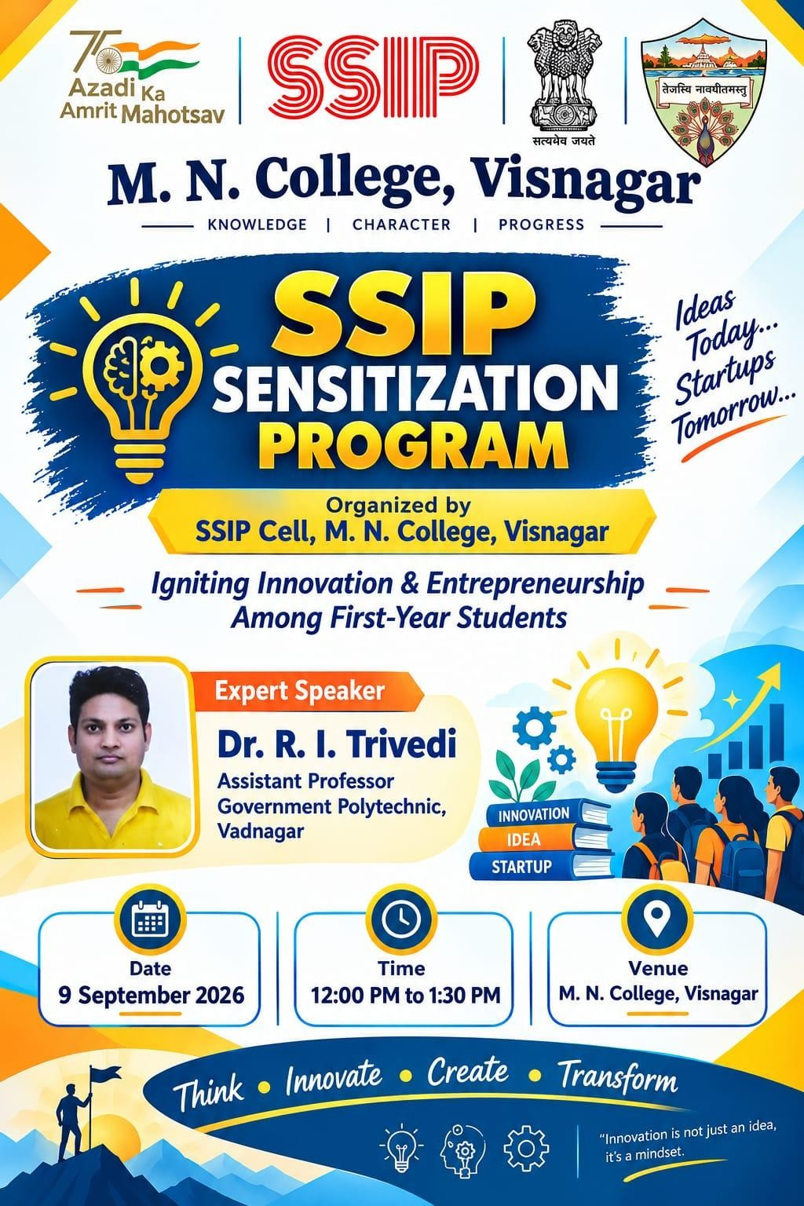
- Introduction
The SSIP Cell of M. N. College, Visnagar organized a SSIP Sensitization Program on “Journey from Innovation to Startup” on 09 September 2026 at the Theatre Hall, S-17, Science Building. The programme was specially organized for newly admitted first-year science students to introduce them to the concept of innovation, entrepreneurship and the opportunities available under the Student Startup and Innovation Policy (SSIP) 2.0 of the Government of Gujarat.
The main purpose of the programme was to encourage students to think beyond conventional classroom learning and identify problems from their surroundings that could be converted into useful ideas, projects, products or startup opportunities. The programme also aimed to make students aware that innovation can begin with a simple observation or a small idea and can gradually develop into a prototype, a proof of concept, an intellectual property asset and finally a startup.
- Inauguration and Welcome
The programme began with a warm welcome to the invited speaker, college authorities, faculty members and students. The session was anchored by Dr. Rajesh Senma, who conducted the programme in a systematic and engaging manner.
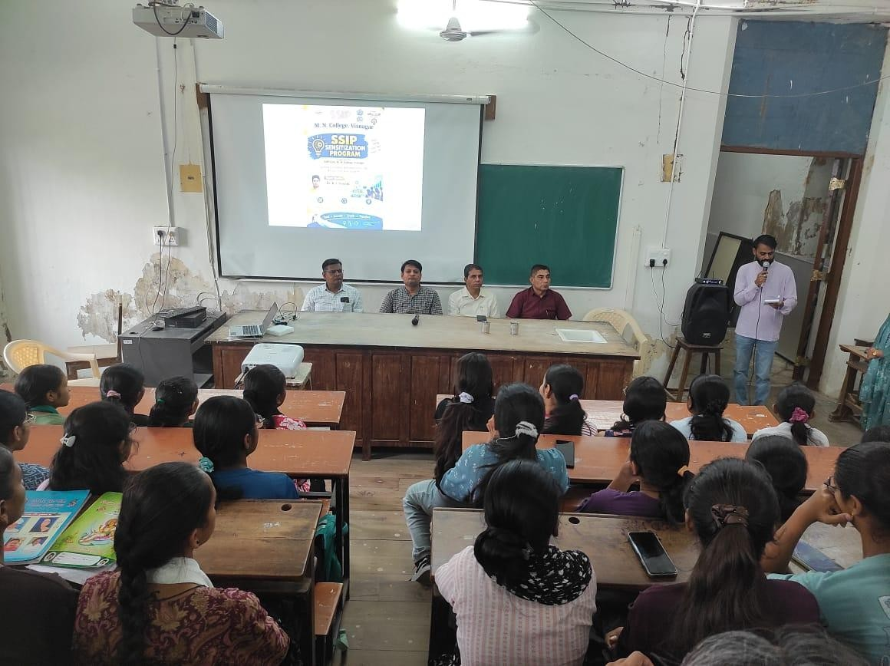
Dr. K. M. Joshi, I/C Science Academic Principal and IQAC Coordinator, addressed the gathering during the inaugural session. He motivated the students to actively participate in innovation and other academic activities offered by the college. He emphasized that college education should not remain limited to textbooks and examinations. Students should observe problems around them, think of practical solutions and make use of the facilities and guidance available in the institution.
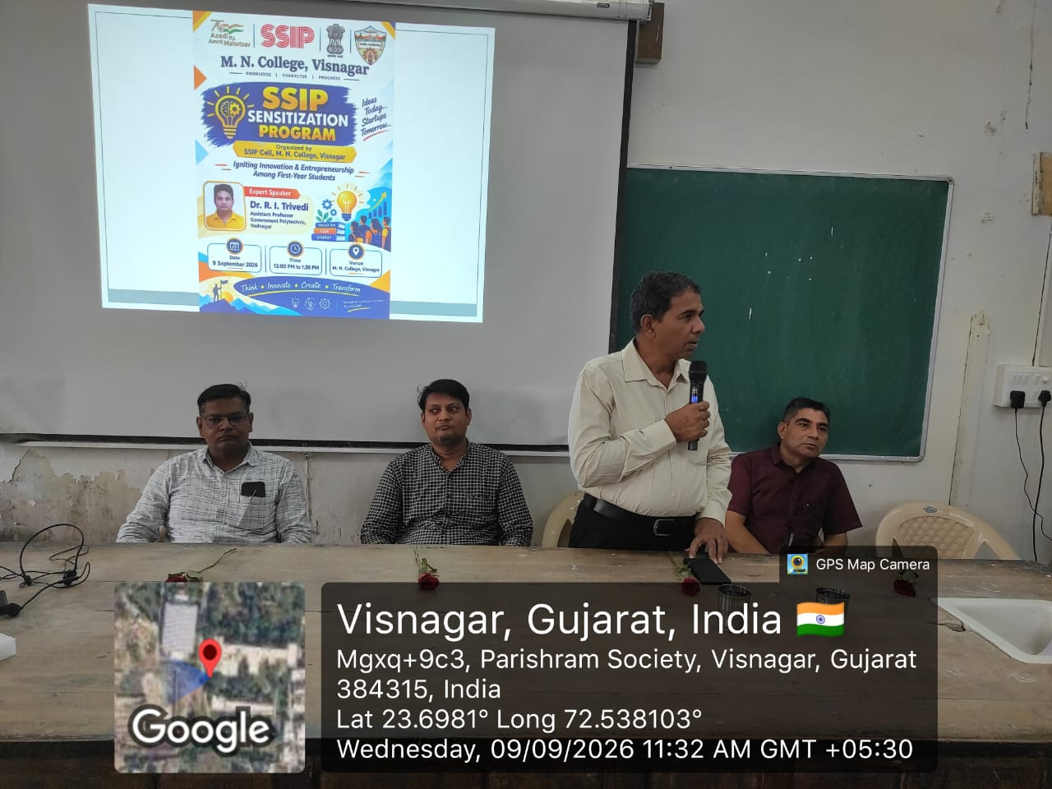
Following this, Dr. Mayur Patel, SSIP Coordinator, introduced students to the role of the SSIP Cell at M. N. College, Visnagar. He explained that students do not need to wait until the final year to think about innovation. Even first-year students can start observing problems, discussing ideas, forming teams and developing their concepts step by step. He encouraged students to approach the SSIP Cell whenever they have an innovative idea and highlighted the support available through SSIP 2.0.
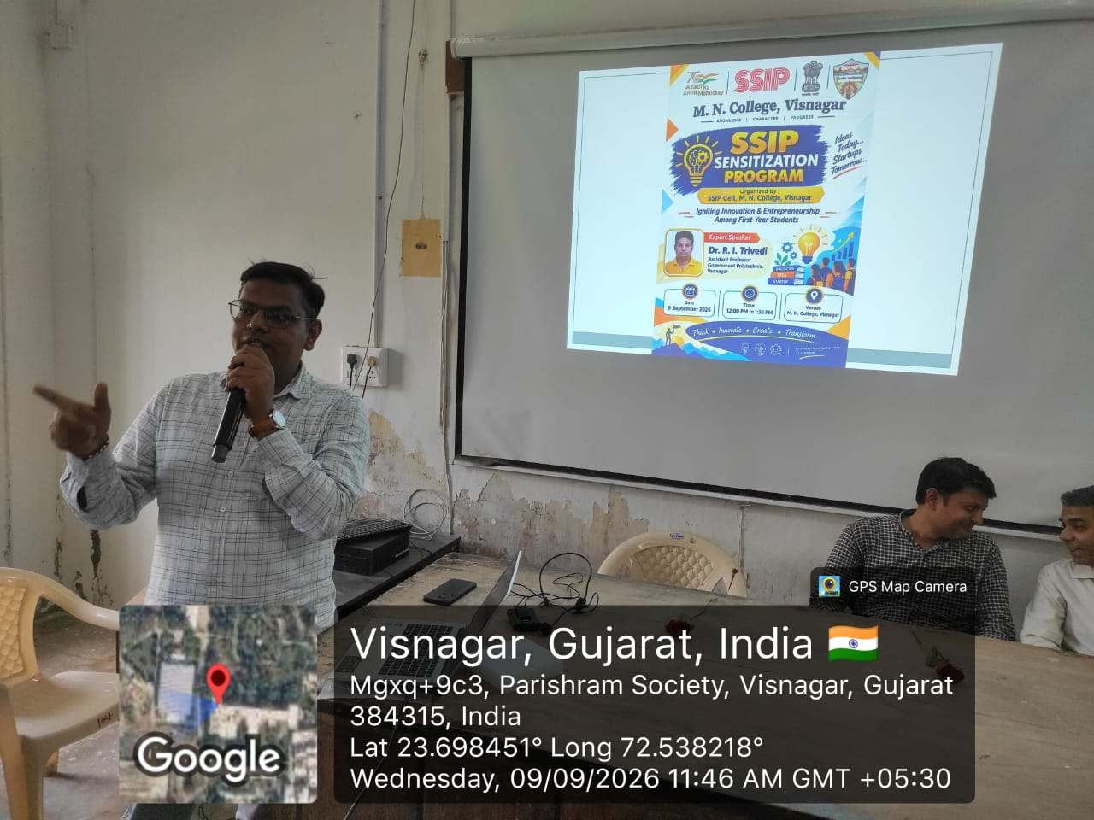
The students were also encouraged to develop a mindset of asking questions such as: What problem can I solve? Can an existing product or process be improved? Can waste be converted into something useful? Can technology make an existing process easier, cheaper or safer? Such questions can become the starting point of innovation.
  - Expert Session: Journey from Innovation to Startup
The main expert session was delivered by Prof. R. I. Trivedi, invited speaker from the Electronics and Communication Department, Government Polytechnic, Vadnagar.
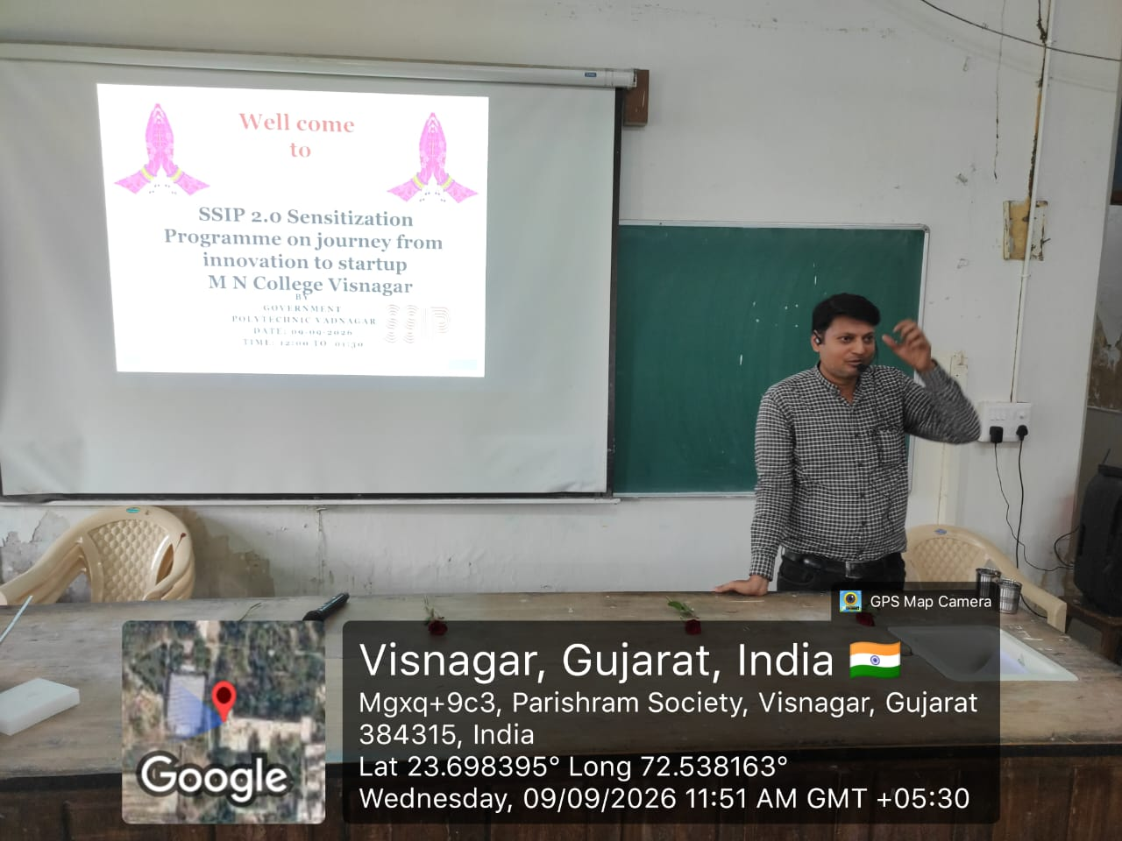
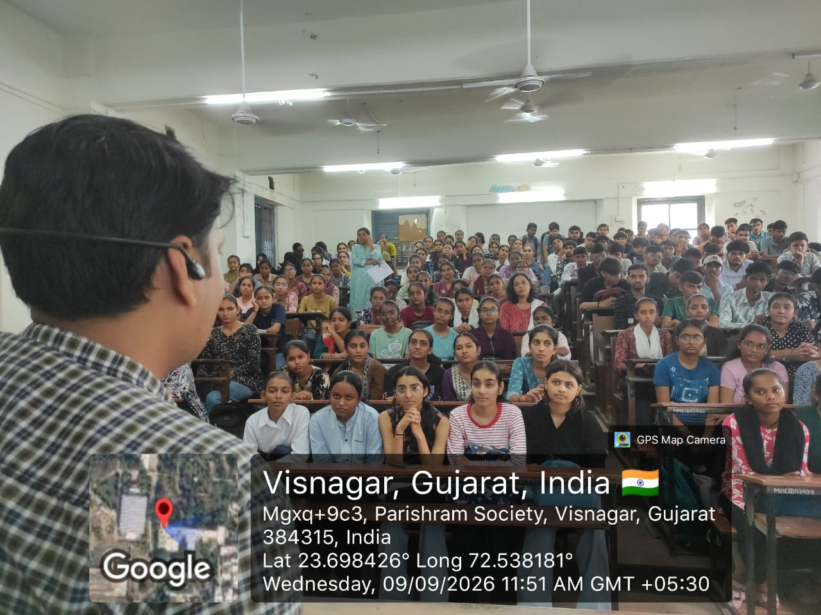
Prof. Trivedi conducted an interactive and student-friendly session on the journey from an initial idea to innovation and finally towards a startup. He explained that invention and innovation are not exactly the same. Invention may involve creating something new, while innovation can also mean improving an existing product, process or service so that it becomes more useful, affordable, efficient or convenient.
He encouraged students to develop out-of-the-box thinking. Through simple visual questions, puzzles and creative thinking activities, he demonstrated how people often remain limited by conventional ways of thinking. Students were encouraged to look at a problem from different viewpoints and not immediately reject an unusual idea simply because it appears different from the usual approach.
  - From an Idea to a Prototype
A major part of the session focused on how an idea can be developed systematically. Students were introduced to the importance of understanding the actual problem before developing a solution. An idea should be tested, improved and validated instead of directly assuming that it will work.
The speaker explained the importance of a Proof of Concept (PoC) and prototype development. A prototype is an early version or model of a proposed solution that helps the innovator understand whether the idea is practically possible. Depending on the idea, a prototype may be a physical model, a digital interface, an application mock-up, a website or another working demonstration.
Students were also encouraged to take feedback from potential users. Feedback can help identify weaknesses in an idea and provide suggestions for improvement before spending large amounts of time and money on final development.
  - Understanding SSIP 2.0 Support
Prof. Trivedi also explained the role of SSIP 2.0 in supporting student innovation and entrepreneurship. Students were made aware that eligible ideas can receive institutional and financial support for activities such as PoC and prototype development. The SSIP framework also provides support related to intellectual property protection, mentoring and incubation.
The students were informed that the innovation journey does not end with developing a prototype. A promising idea can move further towards IPR protection, product development, market validation, Minimum Viable Product (MVP) and startup development.
The session helped students understand the broad journey:
Problem Identification → Idea Generation → Innovation → PoC → Prototype → Testing & Feedback → IPR/MVP → Market Validation → Startup
This step-by-step approach helped students understand that a startup is not created in one day. It is the result of continuous improvement, testing, learning and solving a real problem.
  - Examples of Student Innovation
The discussion was connected with examples of innovation supported through SSIP activities. Students were introduced to different types of ideas such as environment-friendly products, agricultural solutions, natural products, waste utilization, biodegradable alternatives and technology-based solutions.
Examples of projects supported through SSIP include Sarjan–3R, which focuses on reuse of waste clothes; Eco-Bite, based on water-soluble biodegradable toothpaste paper; Black-C, which explores carbonized fibres from LDPE waste; VARNIKA, focusing on stabilized natural food colours; and BeeRaksha, which proposes climate-adaptive beehives for rural India. Such examples demonstrate that innovation can emerge from different academic disciplines and from simple problems observed in everyday life.
The students were encouraged to observe problems related to agriculture, environment, waste management, health, education, daily-use products and local needs. The existing SSIP experience of the college also shows that many student ideas are related to process improvement, agriculture and environmental solutions.
  - Innovation, IPR and Entrepreneurship
Another important message of the programme was the need to protect and develop innovative ideas. Students were introduced to the basic importance of Intellectual Property Rights (IPR). They were advised that when an idea has a novel and useful feature, students should seek proper guidance before publicly disclosing or commercializing it.
The session also helped students understand that entrepreneurship is not limited to starting a large company. A student can begin with a small problem, develop a practical solution, test it with users and gradually build a sustainable business around it.
The programme therefore connected classroom knowledge with practical innovation and entrepreneurship. Science students were particularly encouraged to use their knowledge of chemistry, physics, biology, mathematics, computer science and other disciplines to develop solutions to real-life problems.
  - Interaction with Students
The expert session was followed by interaction with students. Students actively participated in the activities and listened to the discussion on innovation, prototype development and startup opportunities.
The interactive nature of the session helped students understand that they do not need to have a complete business plan or a fully developed product at the beginning. A simple observation can be the first step. The important requirement is the willingness to identify a problem, think creatively, test the idea and improve it with proper guidance.
[INSERT IMAGE 4: Student Interaction / Question-Answer Session]
- Feedback and Conclusion
At the end of the programme, student feedback was collected through the prescribed feedback form under the coordination of Dr. Sejal Joshi. The interaction and feedback provided an opportunity to understand the students' response to the sensitization programme and their interest in innovation and startup-related activities.
The programme concluded with a formal Vote of Thanks delivered by Dr. Nirali Vora and Dr. Sejal Joshi. They expressed gratitude to the invited speaker, college administration, faculty members, organizing team and students for their valuable contribution and participation.
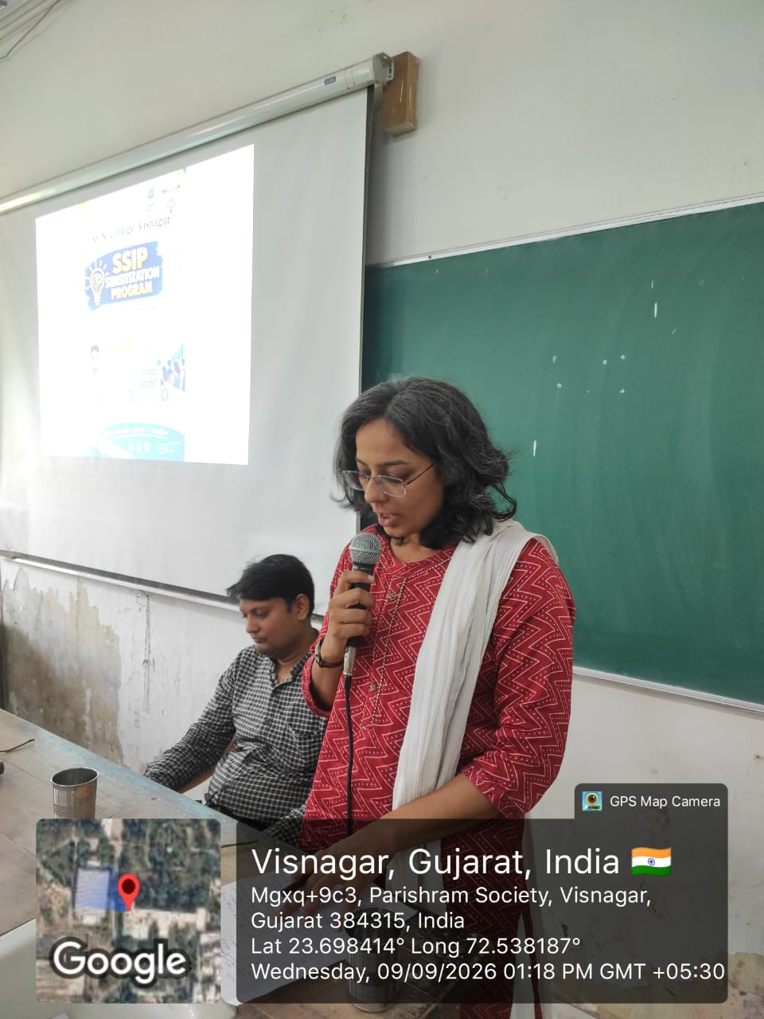
The event successfully introduced 156 first-year science students to the basic concepts of innovation, PoC, prototyping, IPR and entrepreneurship. More importantly, it encouraged students to look at their surroundings with a problem-solving mindset. The programme reinforced the message that a small idea, when properly developed, tested and supported, can become a meaningful innovation and may ultimately lead to a startup.
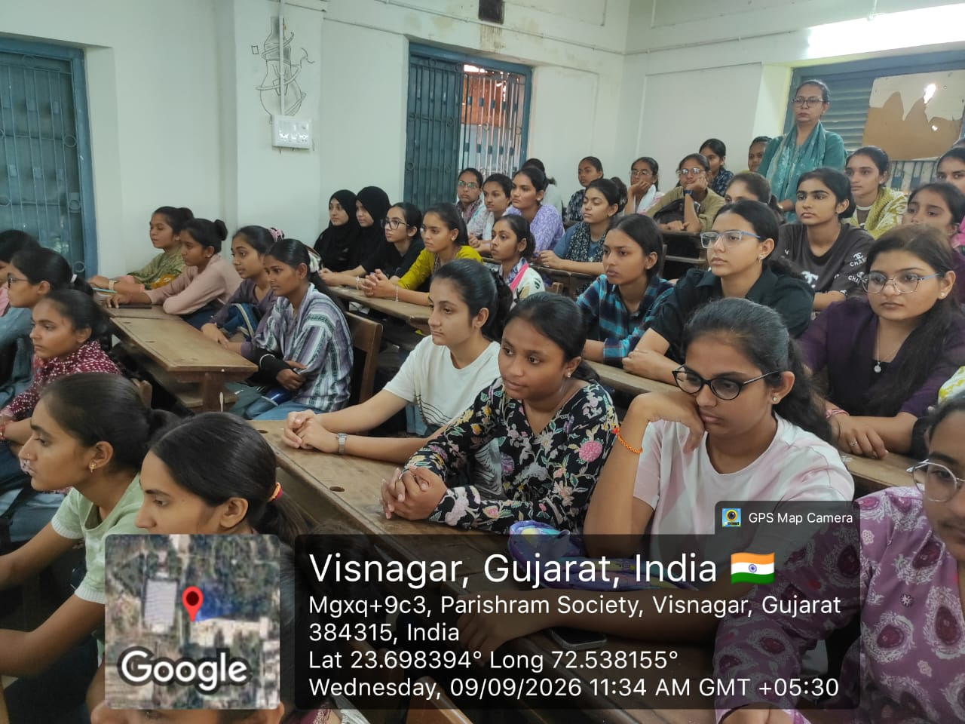
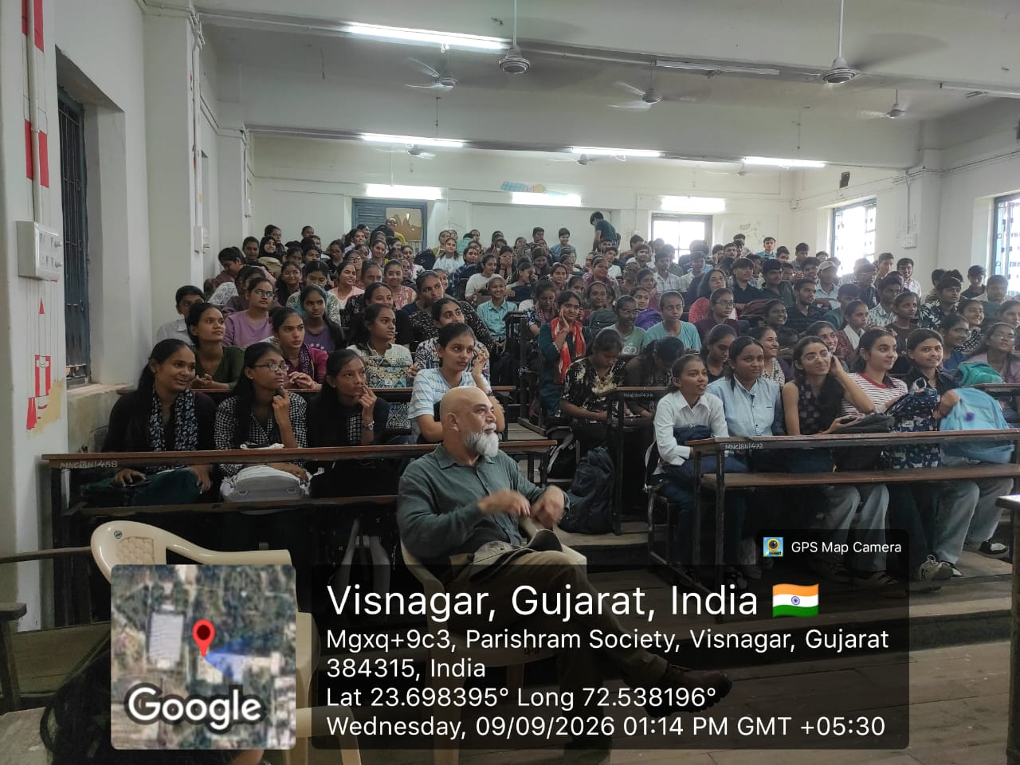
The SSIP Cell of M. N. College, Visnagar aims to continue such sensitization programmes, hands-on activities, expert interactions and mentoring opportunities so that more students can participate in the innovation ecosystem and gradually develop their ideas into practical solutions. This approach is also in line with the future SSIP plans of the institution, which include regular awareness programmes, prototyping and fabrication workshops, stronger expert mentoring, sector-specific innovation and IPR support.
- Event Management and Responsibilities
The programme was successfully coordinated with the support of faculty members assigned different responsibilities:
- Anchoring: Dr. Rajesh Senma
- Photography: Dr. Ishan Khatri
- Student Attendance: Dr. Mittal Choudhary and Dr. Kiran Patel
- Vote of Thanks: Dr. Nirali Vora and Dr. Sejal Joshi
- Feedback Form: Dr. Sejal Joshi
- Speaker Remuneration and Reporting: Dr. Jignesh Dalwadi
- Social Media Coverage: Dr. Mayur Patel
- Department-wise Student Coordination: Prof. Asnani, Prof. Prahlad, Dr. Mittal Choudhary, Dr. Jignesh Dalwadi, Dr. Sejal Joshi, Prof. Kiran Rathod and Dr. Ishan Khatri
- Outcome of the Programme
The programme created awareness among newly admitted students about the opportunities available through SSIP 2.0 and encouraged them to participate in innovation-related activities from the beginning of their academic journey. The session helped students understand the complete journey from identifying a problem to developing an idea, preparing a PoC or prototype, taking feedback, protecting intellectual property and exploring entrepreneurship.
The programme was therefore an important first step towards developing an innovation-oriented and problem-solving culture among students of M. N. College, Visnagar.

Dr. Mayur Patel Dr. R. D. Modh
(SSIP Coordinator) (Principal)

